DATABASE MANAGEMENT
SYSTEMS LAB

REPORT ASSIGNMENT-5

NAME: SOHAM LAHIRI

CLASS: BCSE UG-III 6TH SEMESTER

ROLL NO: 002210501107

GROUP: A3

SUBMISSION DATE: 16/04/2025

Problem Statement 1:
Consider, the following relations:
RESULT(ROLL, SCODE, MARKS), BACKPAPER(ROLL, SCODE)
Write a trigger to do the following:
Whenever a row is inserted or updated in RESULT, if the marks is 50 or more, delete the corresponding row, if any, from BACKPAPER. Otherwise insert a row in BACKPAPER if not already present there.

Entity-Relationship Diagram:

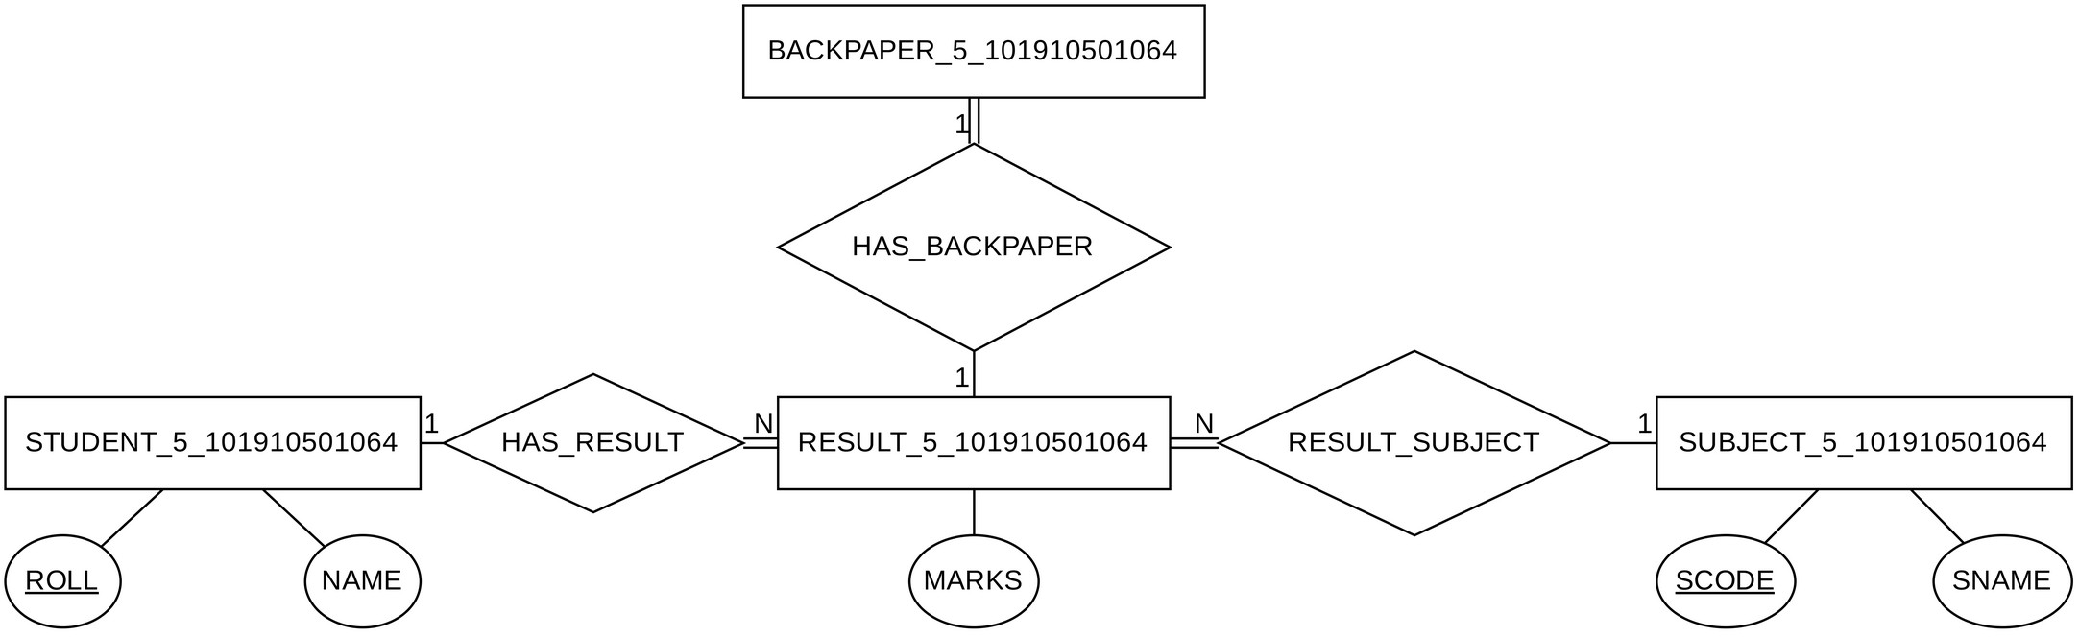

SQL Table Creation Code:
CREATE TABLE STUDENT_5( ROLL CHAR(15) NOT NULL,
NAME CHAR(128) NOT NULL,
CONSTRAINT STUDENT_5_PK PRIMARY KEY(ROLL)
);
INSERT INTO STUDENT_5VALUES ('ST001', 'Soham Lahiri'); INSERT INTO STUDENT_5VALUES ('ST002', 'Ward Moreno'); INSERT INTO STUDENT_5VALUES ('ST003', 'Eddie Hill');

CREATE TABLE SUBJECT_5( SCODE CHAR(5) NOT NULL,
SNAME CHAR(128) NOT NULL,
CONSTRAINT SUBJECT_5_PK PRIMARY KEY(SCODE)
);
INSERT INTO SUBJECT_5VALUES ('SJ001', 'English');
INSERT INTO SUBJECT_5VALUES ('SJ002', 'Computer Science'); INSERT INTO SUBJECT_5VALUES ('SJ003', 'Maths');

CREATE TABLE RESULT_5( ROLL CHAR(15) NOT NULL,
SCODE CHAR(5) NOT NULL, MARKS NUMBER,
CONSTRAINT RESULT_5_PK PRIMARY KEY(ROLL, SCODE), CONSTRAINT RESULT_ROLL_FK
FOREIGN KEY (ROLL) REFERENCES STUDENT_5(ROLL), CONSTRAINT RESULT_SCODE_FK
FOREIGN KEY (SCODE) REFERENCES SUBJECT_5(SCODE), CONSTRAINT RESULT_MARKS_RANGE CHECK (MARKS <= 100)
);

CREATE TABLE BACKPAPER_5( ROLL CHAR(15) NOT NULL,
SCODE CHAR(5) NOT NULL,
--no primary key?
--can we try foreign key references? CONSTRAINT BACKPAPER_ROLL_FK
FOREIGN KEY (ROLL) REFERENCES STUDENT_5(ROLL), CONSTRAINT BACKPAPER_SCODE_FK
FOREIGN KEY (SCODE) REFERENCES SUBJECT_5(SCODE)
); COMMIT;
Creating Insertion/Update/Deletion Trigger for
RESULT_5:
CREATE OR REPLACE TRIGGER RESULT_5_TRIGGER AFTER INSERT OR UPDATE OR DELETE ON RESULT_5FOR EACH ROW
DECLARE
L_MATCH_COUNT INTEGER; L_INSERTFLAG BOOLEAN;
BEGIN
IF INSERTING OR UPDATING THEN
IF :NEW.MARKS >= 50 THEN L_INSERTFLAG := FALSE; ELSE L_INSERTFLAG := TRUE;
END IF;
ELSIF DELETING THEN L_INSERTFLAG := FALSE;
END IF;

IF L_INSERTFLAG THEN
SELECT COUNT(*) INTO L_MATCH_COUNT FROM BACKPAPER_5BP
WHERE BP.ROLL = :NEW.ROLL AND BP.SCODE = :NEW.SCODE;

IF L_MATCH_COUNT < 1 THEN
INSERT INTO BACKPAPER_5(ROLL, SCODE) VALUES (:NEW.ROLL, :NEW.SCODE);
END IF;
ELSE
BEGIN
DELETE FROM BACKPAPER_5BP
WHERE BP.ROLL = :OLD.ROLL AND BP.SCODE = :OLD.SCODE; EXCEPTION
--When nothing to delete WHEN NO_DATA_FOUND THEN
NULL;
END;
END IF;
END;
COMMIT;

Testing our Trigger:

Updating and Deleting:
;

;

;

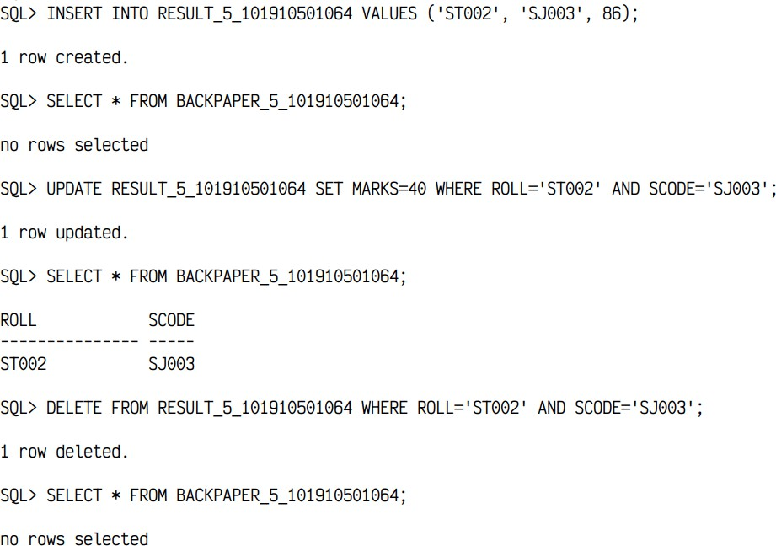

Inserting and Updating:
;

;

;

